**WEEK-01**

**HANDS ON EXERCISES SOLUTIONS**

DATA STRUCTURES AND ALGORITHMS:

1]Exercise 2: E-commerce Platform Search Function

Scenario:

You are working on the search functionality of an e-commerce platform. The search needs to be optimized for fast performance.

Steps:

1. Understand Asymptotic Notation:
   * Explain Big O notation and how it helps in analyzing algorithms.
   * Describe the best, average, and worst-case scenarios for search operations.
2. Setup:
   * Create a class Product with attributes for searching, such as productId, productName, and category.
3. Implementation:
   * Implement linear search and binary search algorithms.
   * Store products in an array for linear search and a sorted array for binary search.
4. Analysis:
   * Compare the time complexity of linear and binary search algorithms.
   * Discuss which algorithm is more suitable for your platform and why.

Solution:

DESCRIPTION:

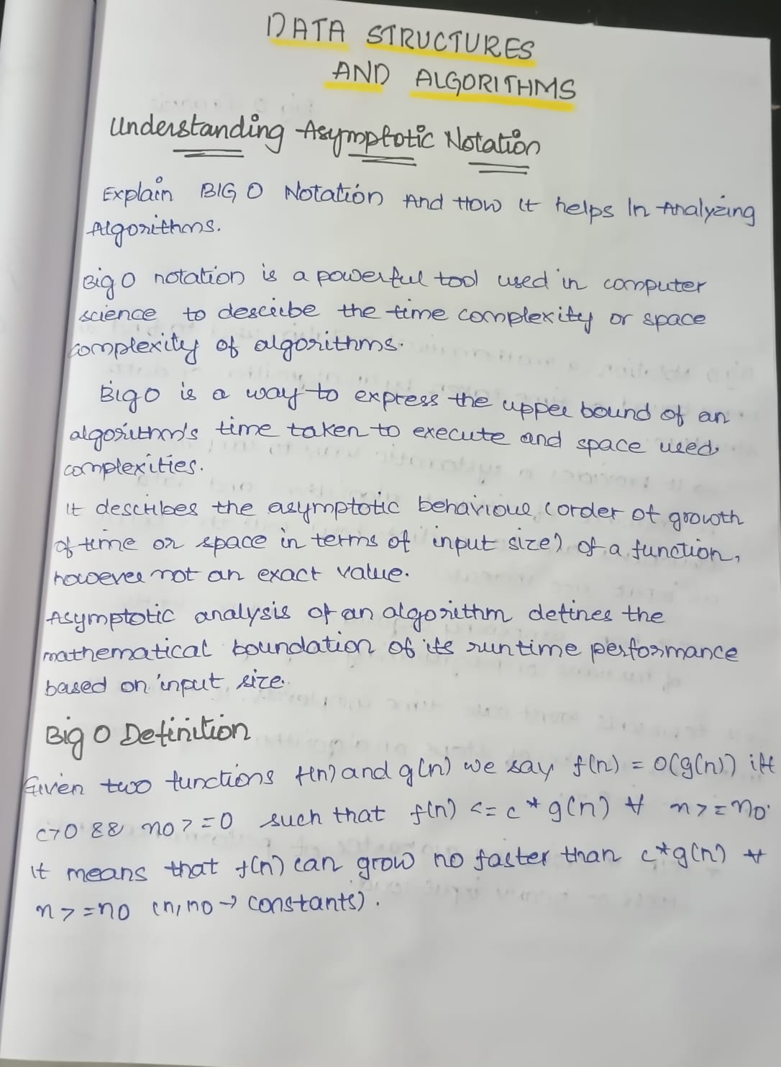

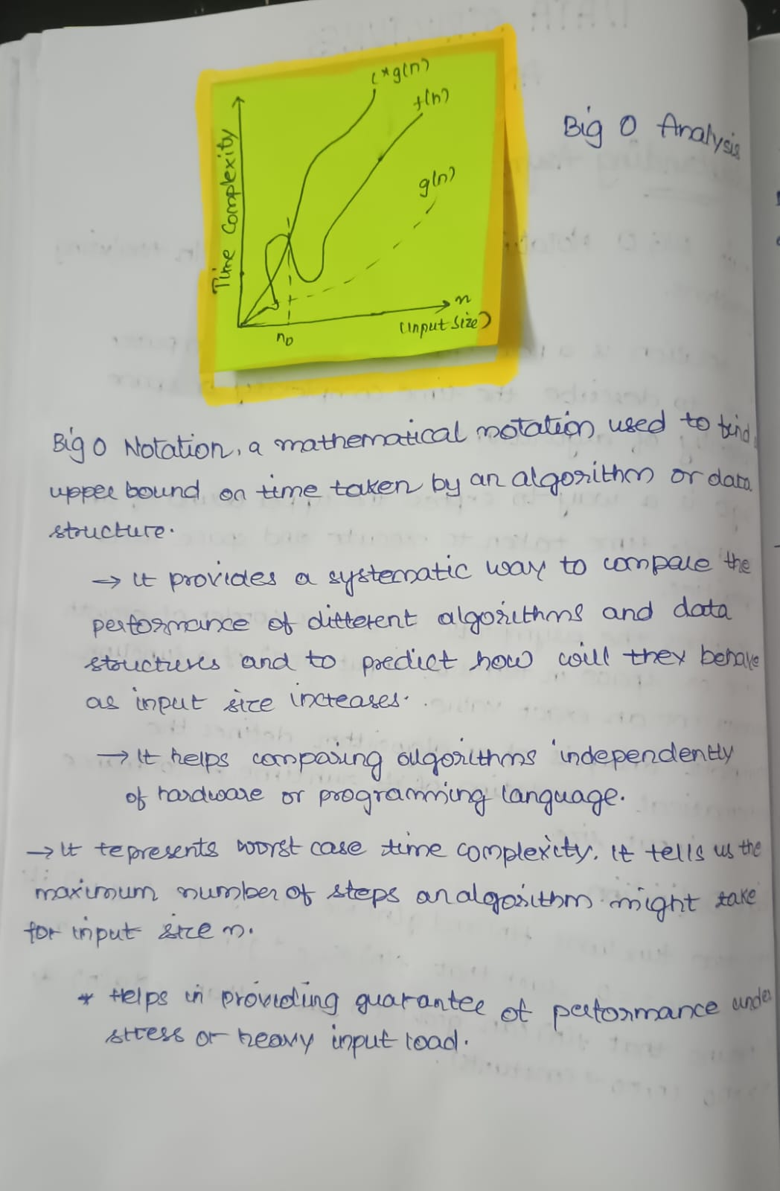

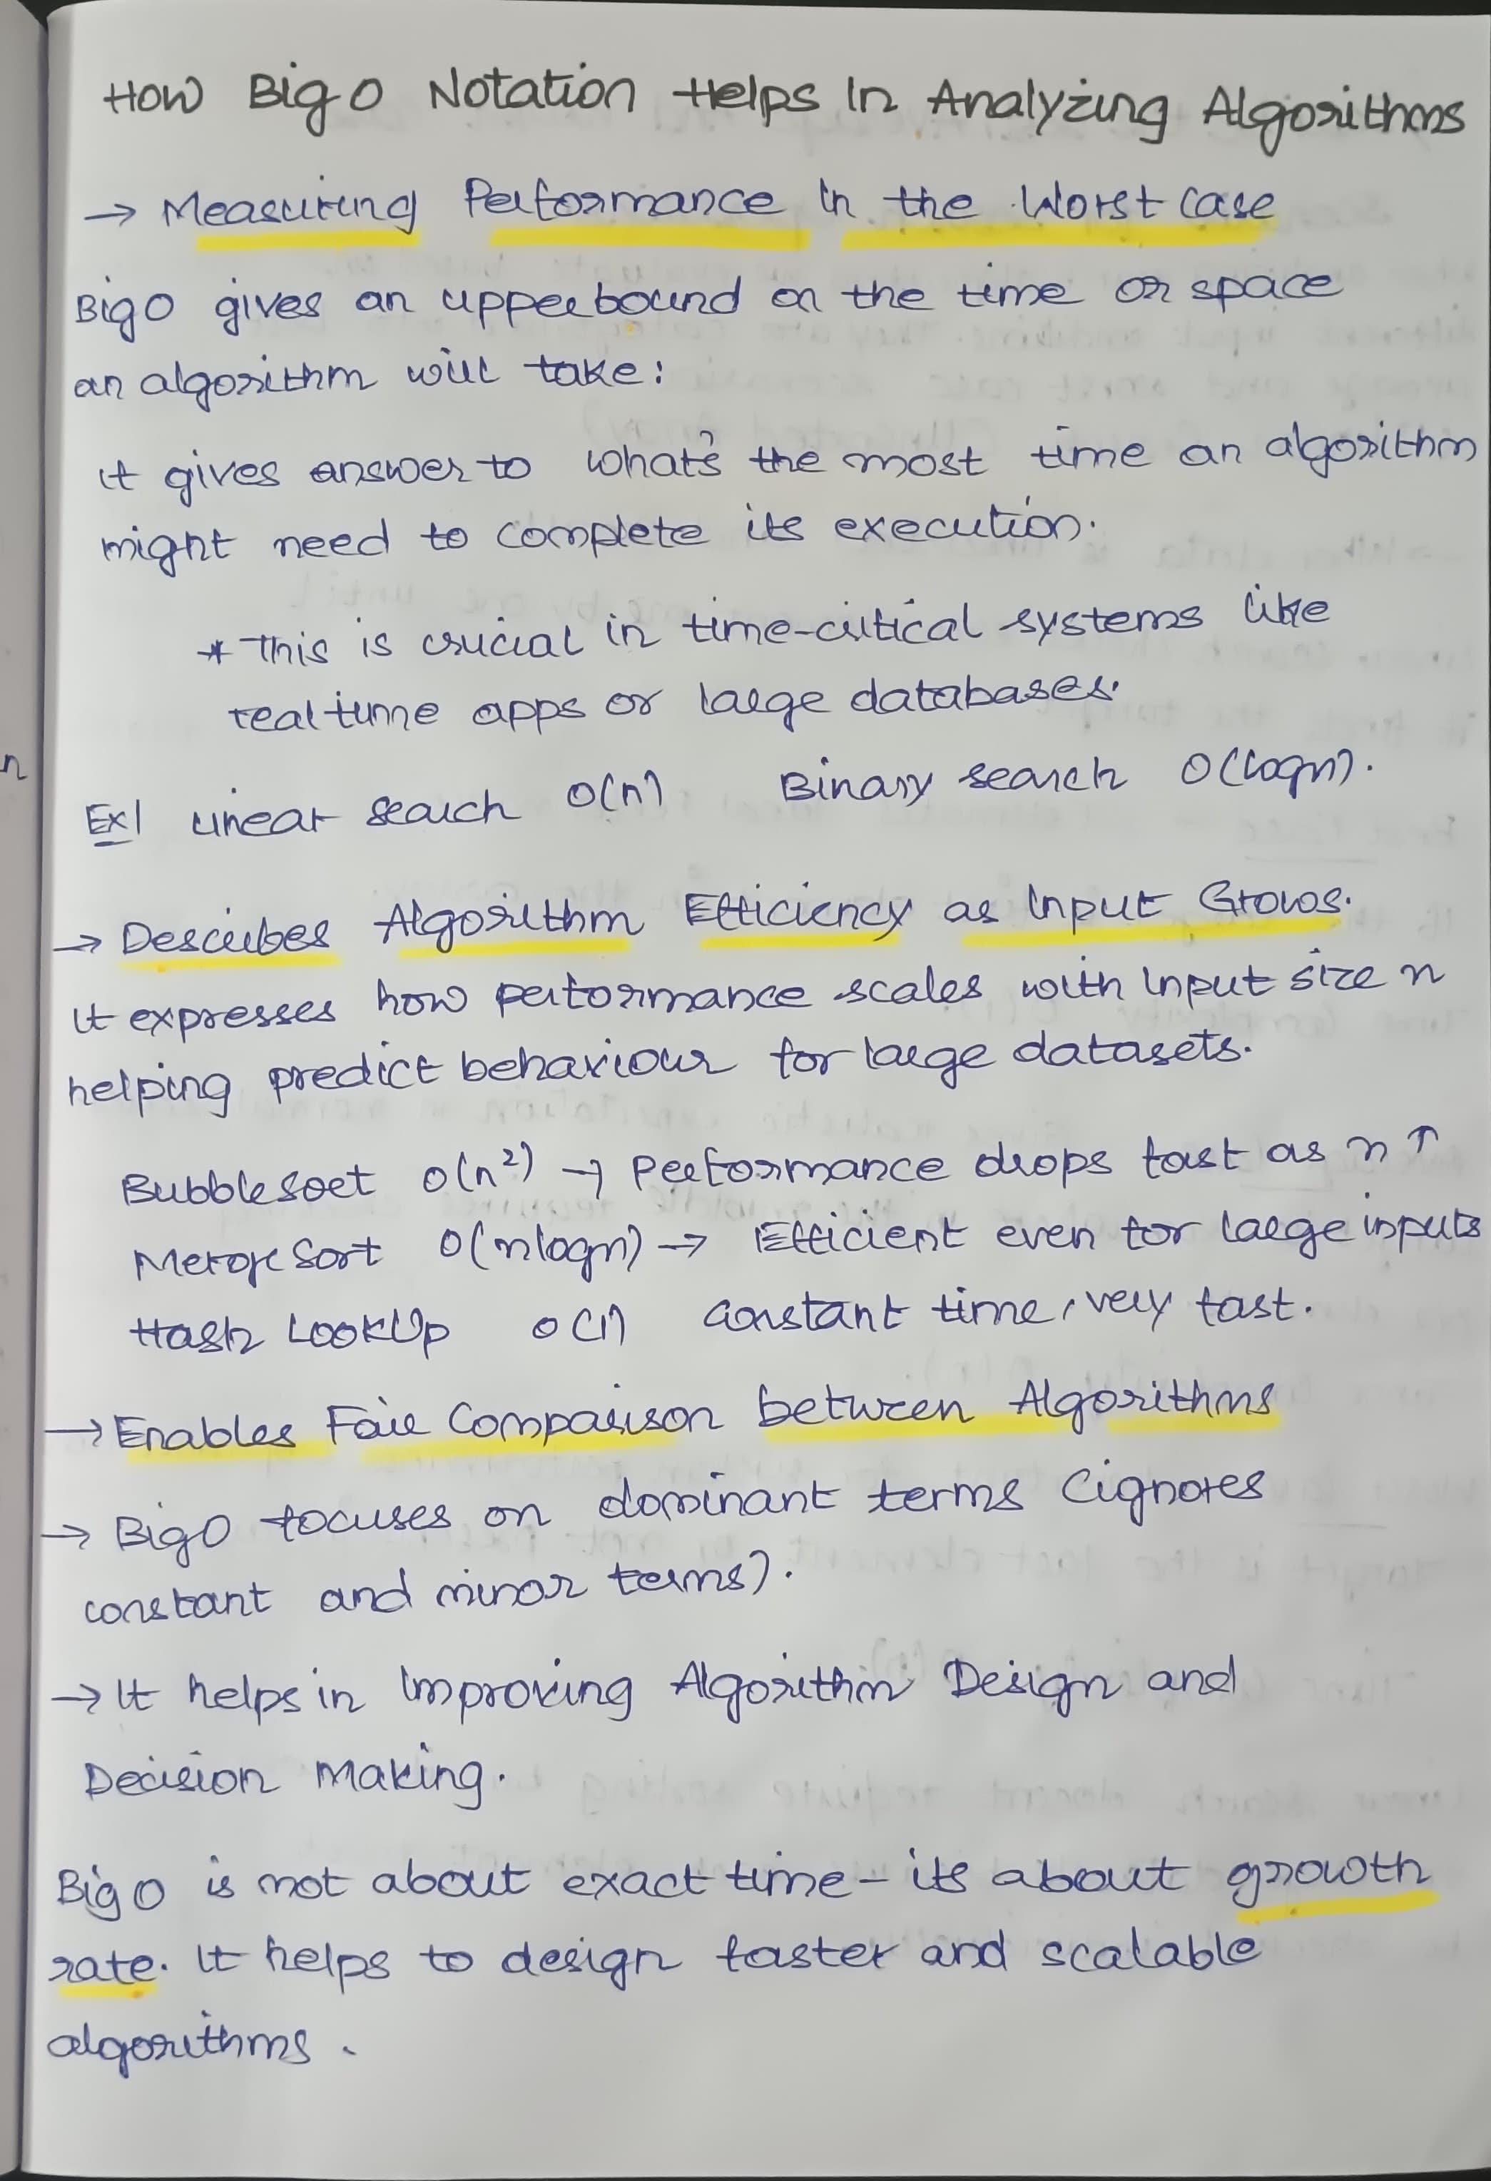

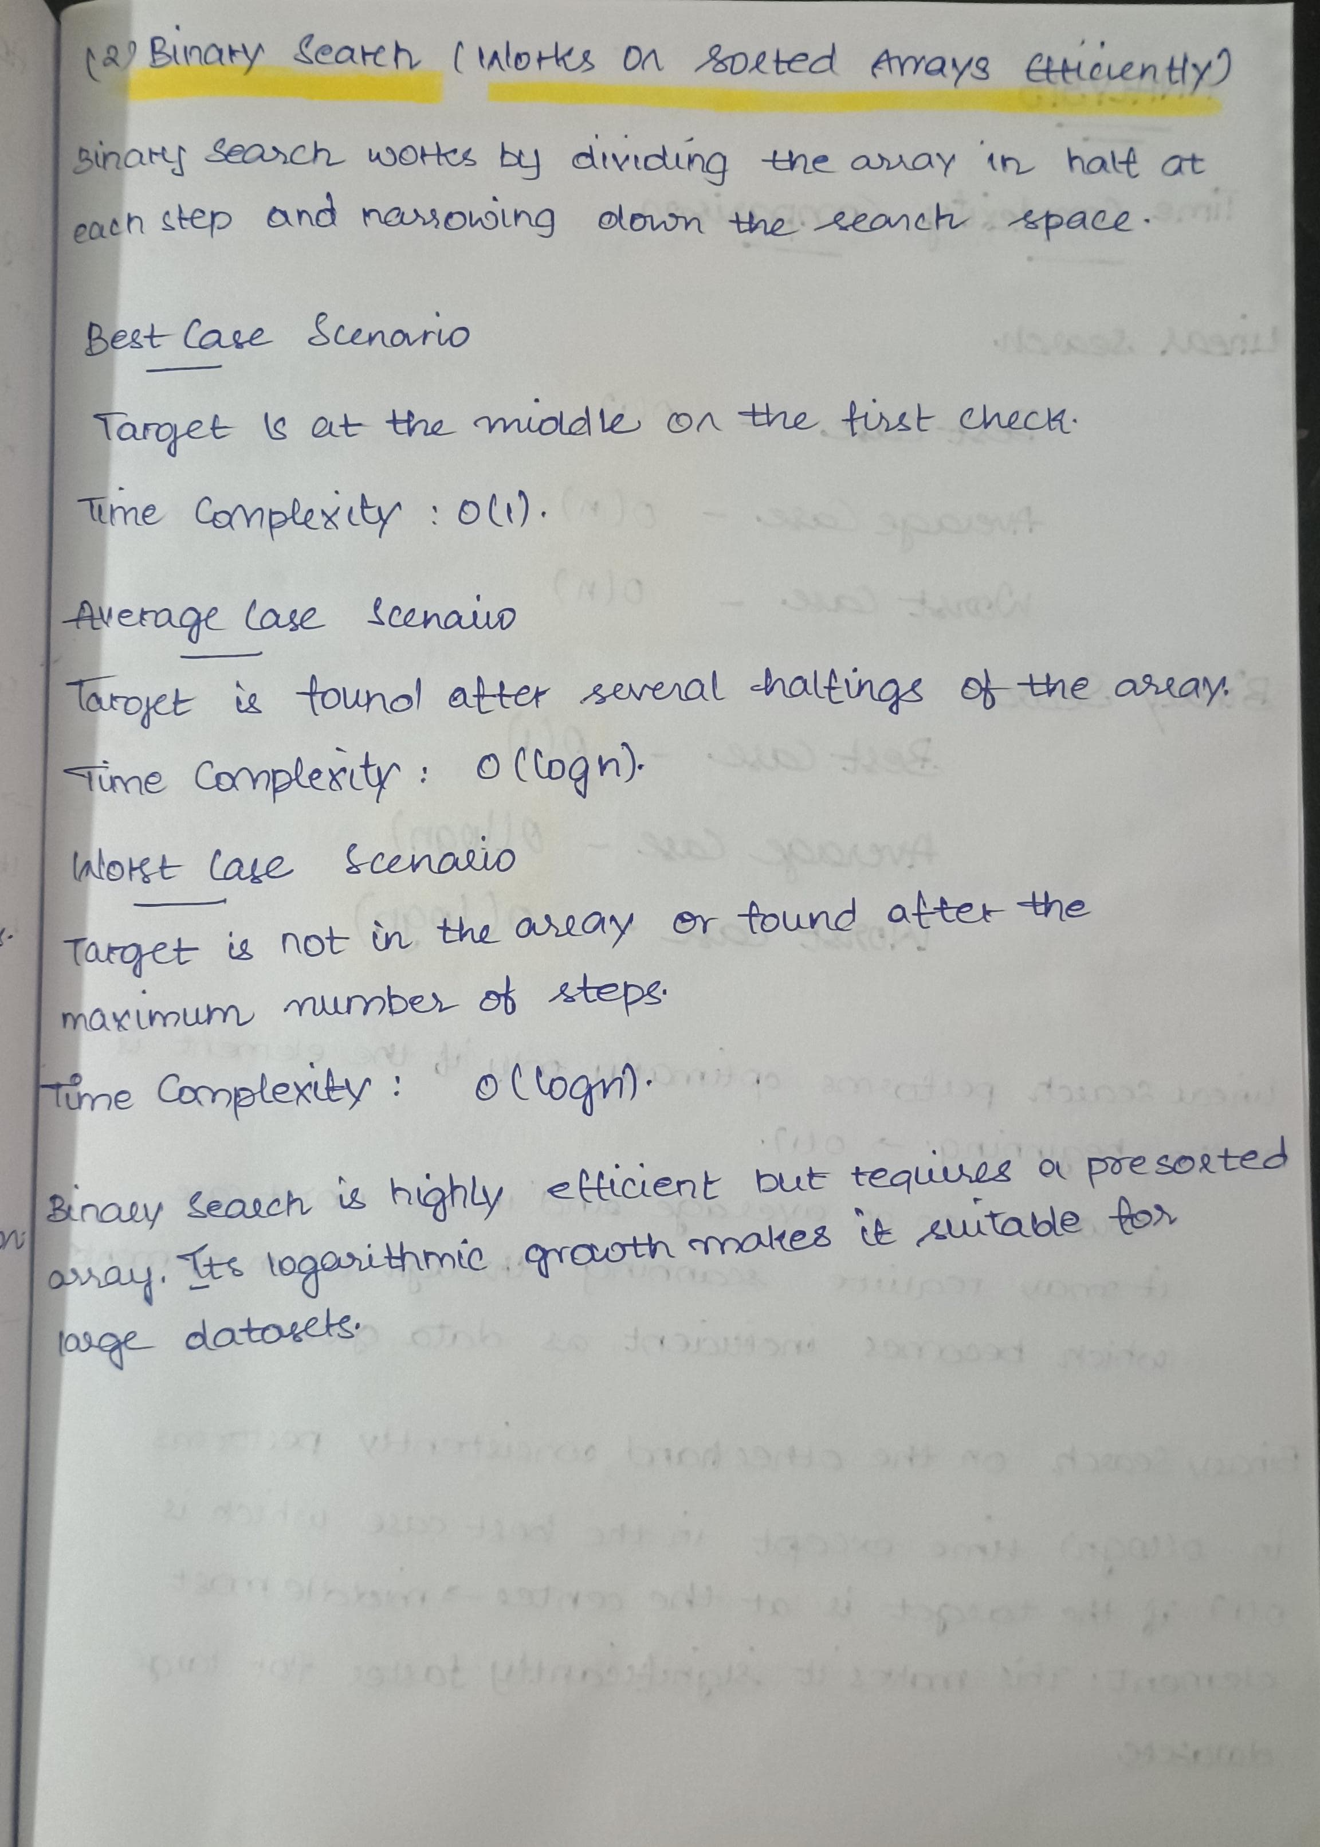

**IMPLEMENTATION:**

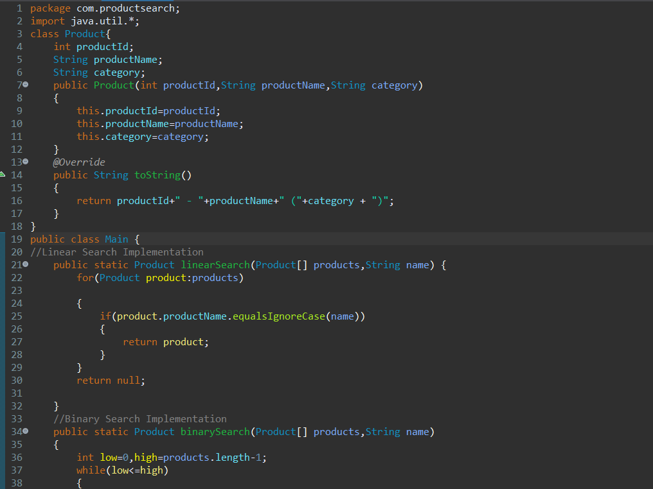

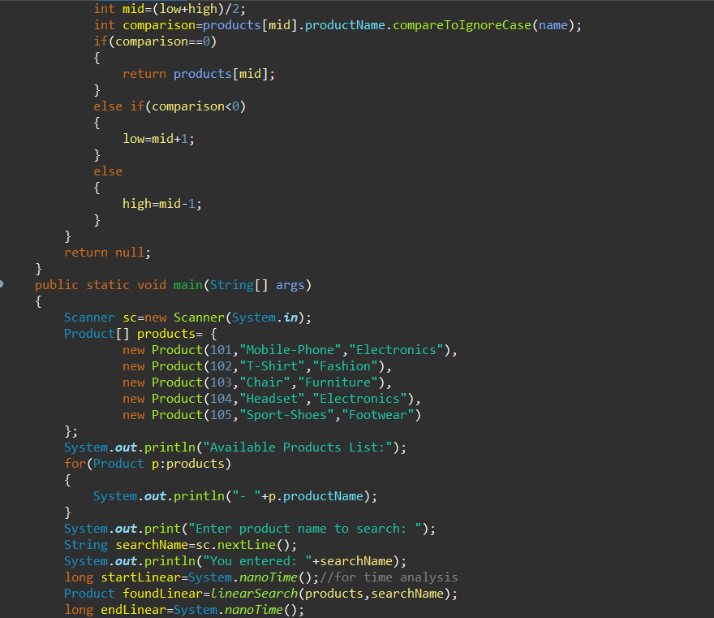

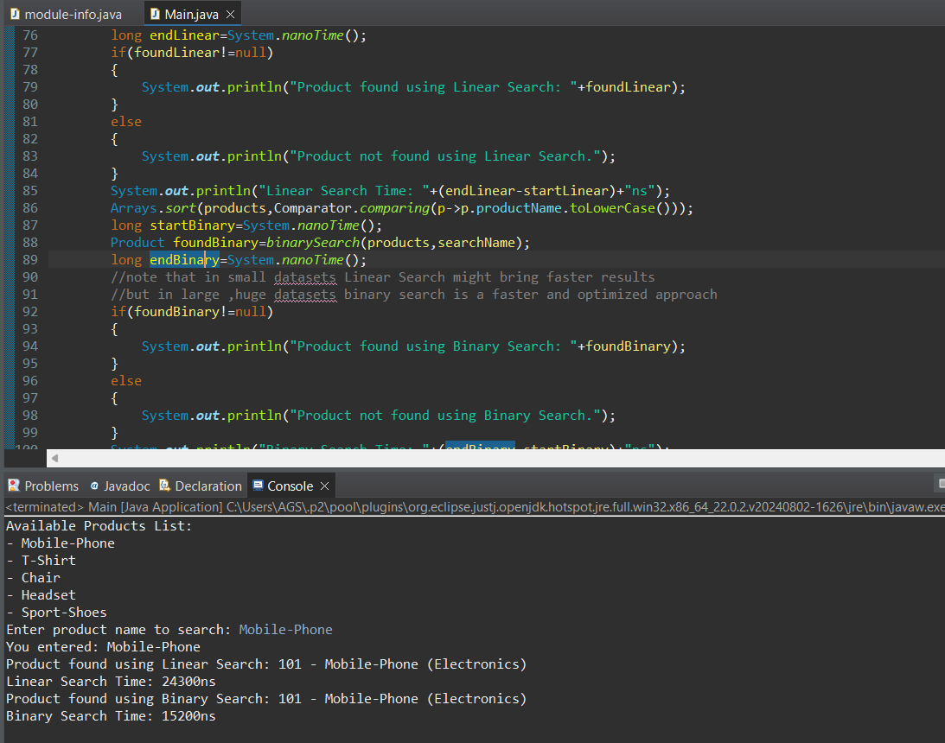

OUTPUT:

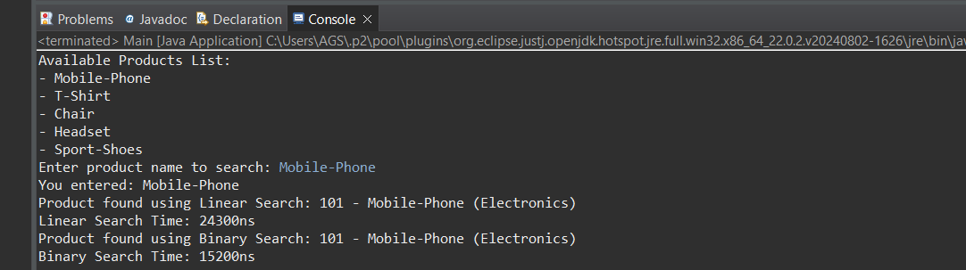

ANALYSIS:

